SPEC NOTE: THESE DRAWINGS ARE TO BE TREATED AS A SPEC NOTE AND ONLY INTENDED TO ASSIST WITH IDENTIFICATION OF COMPONENTS. THEY ARE NOT INTENDED FOR INCORPORATION INTO THE FINAL SPECIFICATION.
HORIZONTAL HCI-Girt (+ VERTICAL PanelRail)
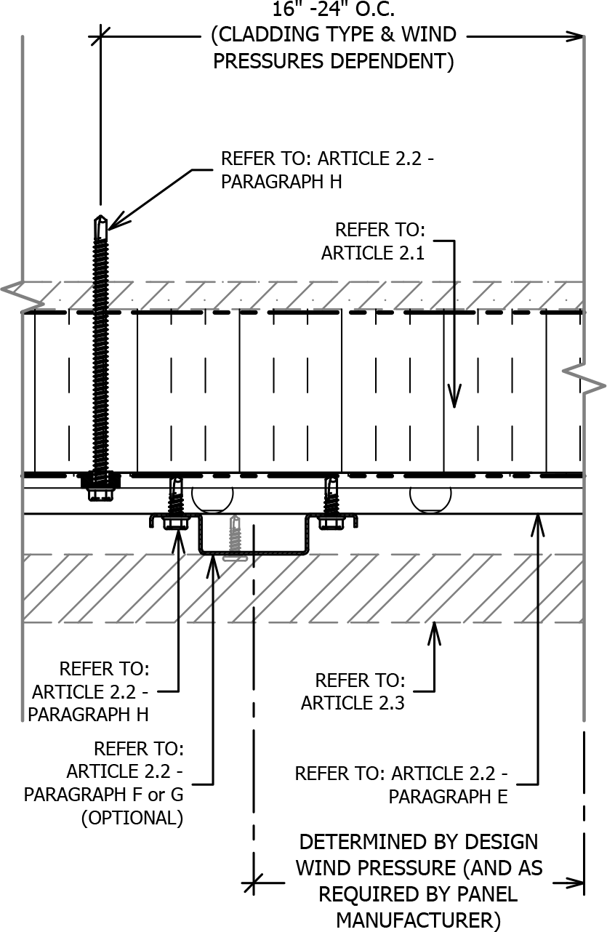
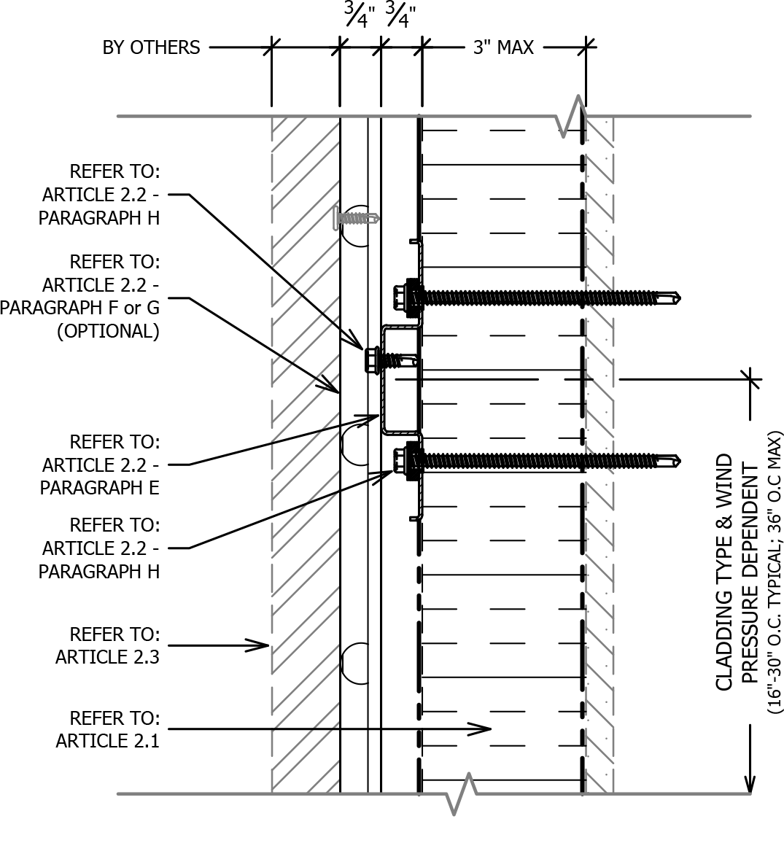
SECTION VIEW
PLAN VIEW

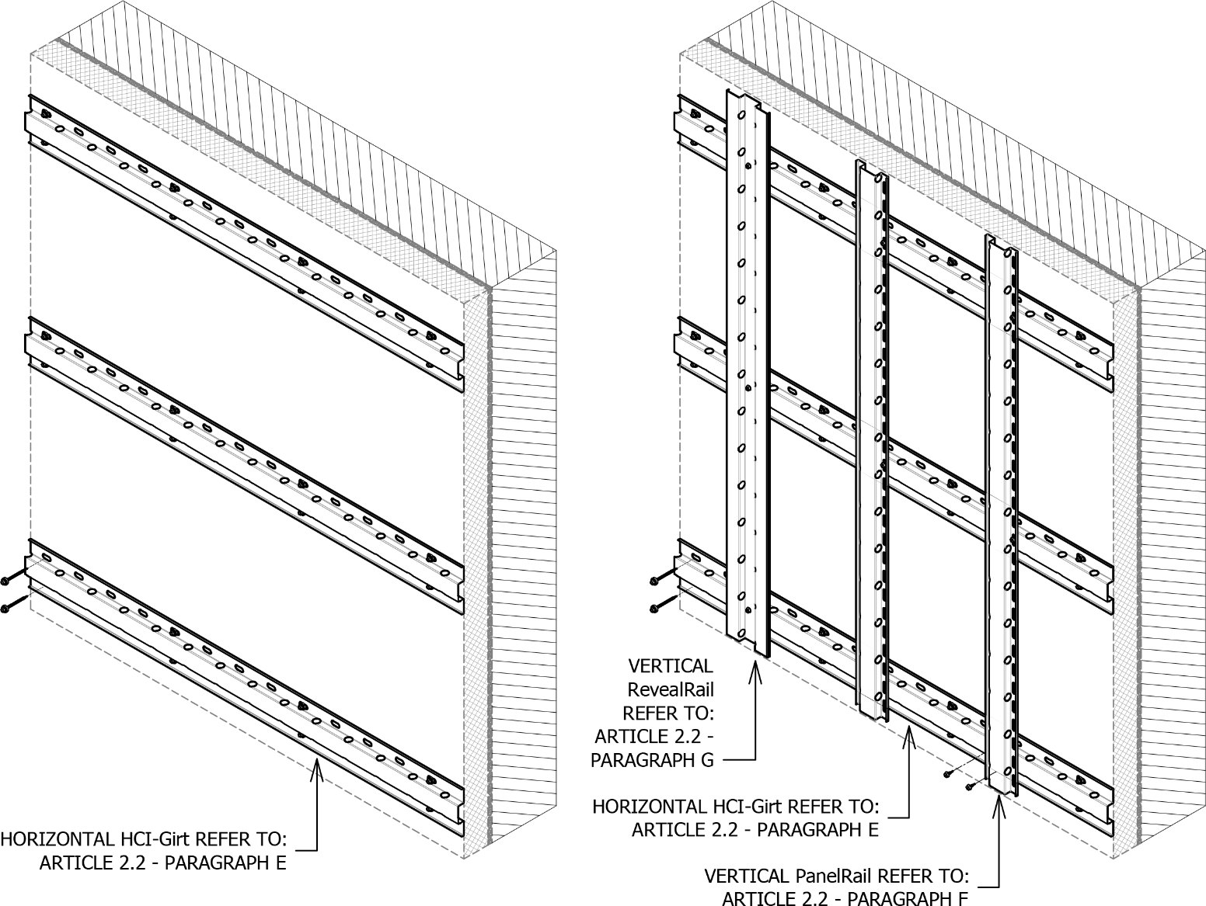

SPEC NOTE: HCITM SYSTEM: HORIZONTAL GIRTS ATTACHED
OVER CONTINUOUS INSULATION:
This guide specification is intended for use when specifying a code compliant, continuously insulated, wall assembly consisting of a fully engineered thermally broken highly corrosion resistant rainscreen attachment system fastened over 25 PSI rigid foam insulation. The system can attach directly to the substrate without exterior insulation as well.
This specification is written with optional secondary rails (PanelRailTM and RevealRailTM) which are vertical rails that attach to the HCITM girts. The cladding size, type, orientation and configuration will determine if this system is required.
This rainscreen attachment system is versatile and suitable for common rainscreen panel assemblies such as (but not limited to) metal panels, fiber cement and Aluminum Composite Material (ACM). Cladding type must meet IBC requirements and weigh not more than 9 PSF. The framing system creates a minimum of 0.75 inch total air cavity for drainage and ventilation.
Please contact manufacture for further information or questions.

KNIGHT WALL SYSTEMS, inc

28308 N. Cedar Road - Deer Park, WA 99006

Toll Free: 1.855.KWS.WALL (597.9255)

Telephone: 509.262.0104

Fax: 509.262.0106

Web: www.knightwallsystems.com

E-mail: info@knightwallsystems.com

General sales: sales@knightwallsystems.com

DISCLAIMER: The manufacturer has reviewed the product information contained in this guide specification. The information is organized and presented to assist the specification writer working on a construction project to select the appropriate products and to save time in writing the project specification Section. The specification writer is responsible for product selection as well as the use and application of this information, and should contact the manufacturer to ensure that all options are available and that the associated specification information is valid and correct.

SECTION 07 48 00
RAINSCREEN ATTACHMENT SYSTEM (HCITM + VERTICAL GIRTS)
- General
  - Summary
    - Provide a thermally broken, rainscreen attachment system for attachment of exterior cladding [INSERT TYPE OF CLADDING] installed over continuous exterior-insulation.
    - Related Sections:
      - Refer to Division 05 Section “Steel Stud Framing”.
      - [Refer to Division 06 Section “Rough Carpentry” for wood framing.]
      - [Refer to Division 06 Section “Sheathing”.]
      - Refer to Division 07 Section “Air Barrier”.
      - Refer to Division 07 Section “[INSERT TYPE Siding/Cladding Panel]”.
      - Refer to Division 07 Section “Thermal Insulation” for exterior continuous insulation.
      - [Refer to Division 07 Section “Spray Applied Polyurethane Insulation”.]
  - SYSTEM description
    - System assembly shall include the following components from the substrate out:
      - [Spray polyurethane foam (applied to interior wall cavity for steel stud wall framing).]
      - Substrate: Wall framing assembly [and sheathing] [Concrete masonry unit wall] [Concrete wall].
      - Weather Resistant/Air Barrier [over substrate OR over continuous insulation].
      - Continuous insulation.
      - Thermally broken rainscreen attachment system.
      - Exterior cladding.
    - Design Requirements:
      - Manufacturer is responsible for designing system, including anchorage to structural system and necessary modifications to meet specified requirements and maintain visual design concepts.
      - Employ registered professional engineer, licensed to practice engineering in jurisdiction where Project is located, to engineer each component of rainscreen attachment system.
      - Structural Design: Exterior-insulated rainscreen wall assembly capable of withstanding effects of load and stresses from dead loads, wind loads, ice loads (if applicable) as indicated on Structural General Notes on Structural Drawings, and normal thermal movement without evidence of permanent defects of assemblies or components.
        - Thermal Movements: Provide assemblies that allow for thermal movements resulting from the following maximum ambient temperatures by preventing overstressing of components and other detrimental effects:
          - Temperature Change (range): 120 degrees Fahrenheit (67 degrees C), ambient:
      - Support Framing/Attachment System:
        - No framing component may penetrate the layer of continuous exterior insulation other than thermally isolated fasteners.
        - Frequency and spacing of stiffened horizontal girts as indicated by manufacture in project specific engineering package.
    - Performance Requirements:
SPEC NOTE: COORDINATE WITH COMPLETE WALL ASSEMBLY TO DETERMINE APPLICABLE THERMAL PERFORMANCE CRITERIA TO SUIT PROJECT REQUIREMENTS, INCLUDING TOTAL WALL EFFECTIVE R-VALUE (U-FACTOR) REQUIRED.
      - Rainscreen Attachment System Performance: Comply with ANSI/ASHRAE 90.1-2010 definition of continuous insulation (c.i.).
      - No thermal bridges other than fasteners and service openings.
      - Thermal Performance:
        - Full constructed assembly must have a minimum 90% EFFECTIVE R-value when compared to the exterior continuous insulations rated R-Value.
        - Continuous framing profiles (including C- or Z-shaped sections or furring) penetrating insulation not allowed.
        - Perform effective R-Value calculation or modeling in accordance with ASHRAE guidelines.
SPEC NOTE: WALL ASSEMBLY EFFECTIVE R-VALUE SHOULD BE IN ACCORDANCE WITH ASHRAE 90.1-2010 REQUIREMENTS OR LOCALLY ADOPTED VERSION. FOR EXAMPLE IN CLIMATE ZONES 4-8 FOR STEEL FRAMED BUILDINGS THE EFFECTIVE R-VALUE IS 15.63 (U-0.064).
        - Wall Assembly effective R-Value (U-Factor): [INSERT R-VALUE (U-0.XXX)]
      - Framing Members:
        - Test framing components to AAMA TIR- A8-[04] – Section 7.2 to determine structural performance and effective moment of inertia for each perforated component. Minimum Effective Moment of Inertia: 0.0150 in⁴.
        - Localized bending stress for eccentrically loaded framing members must be evaluated with the maximum effective length of resisting element not more than 12 inches.
      - Fasteners:
        - Minimum Safety Factor of 3 for both tension and shear values.
        - Combined tension and shear shall be evaluated according to an interaction formula. Sum of terms shall not exceed 1.0.
  - SUBMITTALS
    - Product Data: Submit manufacturer’s product literature and descriptions of testing performed on system components to indicate meeting or exceeding specified performance.
    - Shop Drawings:
      - Submit connection details to the cladding manufacturer, showing interface of rainscreen attachment system to substrate and panels with adjacent construction, signed and sealed by Professional Engineer.
      - Show system installation and attachment, including fastener size and spacing.
    - Structural Calculations:
      - Submit rainscreen attachment manufacturer’s comprehensive Structural Design analysis signed and sealed by a Professional Engineer.
    - Samples: Submit following material samples for verification:
      - Horizontal Vented Stiffened Girts: Two (2) 12-inch long samples.
      - [Vertical Rails: Two 12-inch long samples of each.]
    - Test Reports:
      - Test to the following standards and provide written test reports by a third party:
        - AAMA TIR-A8-[04]: Structural Performance of Composite Thermal Barrier Framing Systems – Section 7.2.
      - Comprehensive three-dimensional thermal modeling report indicating framing systems impact on exterior insulation rated R-value.
  - QUALITY ASSURANCE
    - Manufacturer Qualifications:
      - Minimum 5 years’ experience specializing in the manufacturing of façade attachment/support framing similar to those specified.
      - Ability to demonstrate conformance to testing requirements.
    - Installer Qualifications:
      - Minimum of 3 years’ documented experience or minimum of 5 completed projects of equivalent scope and quality and recommended by manufacturer to perform work of this Section.
      - Onsite superintendent or foreman overseeing installation on site during entire work of this Section with experience equivalent to installer and in good standing with the manufacturer.
    - Engineer Qualifications: Registered professional engineer experienced in the design of curtain wall systems, anchors, fasteners and licensed to practice engineering in the jurisdiction where Project is located.
    - Pre-Installation Meeting:
      - Discuss sequence and scheduling of work and interface with other trades.
      - Review metal wall framing assemblies for potential interference and conflicts and coordinate layout and support provisions for interfacing work.
      - Review and document methods, procedures and manufacturer’s installation guidelines and safety procedures for exterior wall assembly.
    - Mock-Ups: Coordinate mock-up materials and requirements with mock-up specified in Division 01 [and exterior cladding specification].
  - Quality control
    - Single source responsibility:
      - Furnish engineered rainscreen attachment system components under direct responsibility of single manufacturer.
    - Field Measurements: Verify actual supporting and adjoining construction before fabrication.
    - Record field measurements on project record shop drawings.
    - Established Dimensions: Where field measurements cannot be made without delaying work, guarantee dimensions and proceed with fabrication of rainscreen attachment system corresponding to established dimensions.
  - DELIVERY, STORAGE AND HANDLING
    - Delivery: Deliver materials and components in manufacturers’ original, unopened and undamaged containers or bundles, fully identified. Exercise care to avoid damage during unloading, storing and installation.
    - Store, protect and handle materials and components in accordance with manufacturer recommendations to prevent damage, contamination and deterioration. Keep materials clean, dry, and free of dirt and other foreign matter, and protect from damage due to weather or construction activities.
  - SEQUENCING
    - Ordering: Comply with manufacturers’ ordering instructions and lead time requirements to avoid construction delays.
    - Coordinate construction to ensure that assemblies fit properly to supporting and adjoining construction; coordinate schedule with construction in progress to avoid delaying work.
  - WARRANTY
    - Manufacturer Warranties:
      - Attachment System: Ten (10) year Limited Warranty.
        - Covers components of the attachment system, including structural failure of components when all the materials and components are supplied and installed per manufacturer’s requirements.
        - Includes labor and material for removal and replacement of defective material.
        - Includes labor to remove and reinstall façade finish panels, finish closures and façade finish accessories necessary to access defective material.
    - Contractor’s Warranties: 2-year labor warranty, starting from [date of Owner acceptance of completed work] [Substantial Completion], to cover repair of materials found to be defective as a result of installation errors.
    - Limitation of Warranties: Exclude repairs, replacement, and corrective work to the substrate, primary structure, finish panels, and/or property – unless otherwise noted above. Warranties exclude mechanical damage due to abuse, neglect, primary structure failure, or forces of nature greater than normal weather conditions.
  - MAINTENANCE
    - Extra Materials: For use by Owner in building maintenance and repair, provide [a recommended percentage of] [3 percent] additional rainscreen attachment components in new, unopened cartons, packaged with protective covering for storage and identified with appropriate labels.
- PRODUCTS
  - RIGID INSULATION
SPEC NOTE: SPECIFIER MAY INCLUDE BASIS OF DESIGN RIGID INSULATION HERE OR IN DIVISION 07 SECTION THERMAL INSULATION. INSULATION TYPES THAT WORK WITH THE SYSTEM INCLUDE BUT ARE NOT LIMITED TO THERMAXTM CI, THE DOW CHEMICAL COMPANY; EnergyShield PRO, ATLAS ROOFING CORPORATION; ECOMAXci, RMAX; Xci Class A, HUNTER PANELS; ETC. IF INSULATION IS SPECIFIED HERE, INCLUDE ACCESSORIES SUCH AS FASTENERS, WASHERS, AND TAPES.
RIGID FOAM PLASTIC INSULATION USED IN CONJUNCTION WITH THE HCI-GIRT MUST HAVE COMPRESSION STRENGTH OF 25 PSI PER ASTM D1621. REVIEW CODE REQUIREMENTS OF FOAM PLASTIC, INCLUDING FIRE.
    - Refer to Section 07 21 00 – Thermal Insulation.
  - RAINSCREEN ATTACHMENT/SUPPORT FRAMING system
    - Comply with ANSI/ASHRAE 90.1-2010 definition of continuous insulation (c.i.).
    - Coating Material: ASTM A1046, Zinc-Aluminum-Magnesium, minimum thickness ZM40.
      - ASTM A653 Galvanized steel is not acceptable.
    - Steel Classification: Structural Steel (SS), Grade 50, 50 ksi Yield.
SPEC NOTE: HORIZONTAL GIRTS MAY BE SPACED UP TO 36 INCHES ON CENTER VERTICALLY (DEPENDING ON CLADDING WEIGHT & DESIGN WIND PRESSURES) AND SUPPORT CLADDINGS THAT WEIGH UNDER 9 POUNDS PER SQUARE FOOT. THE MAXIMUM ALLOWABLE SPACING AND DEAD LOAD IS DETERMINED PER PROJECT. THIS IS A FUNCTION OF THE LIVE LOAD PLUS THE DEAD LOAD BEING EQUAL TO LESS-THAN THE ALLOWABLE LOAD PER WALL ANCHOR. SPACING AND MAXIMUM LOADS ARE TYPICALLY DETERMINED BY THE MANUFACTURER.
    - Spacing: Comply with manufacturer’s Professional Engineer’s calculations.
    - Horizontal Girt: Stiffened horizontal girt with pre-punched drainage holes, directly attached on top of rigid insulation [directly to substrate] at regular spacing, with engineered thermally isolated washer assembly and fasteners.
      - Steel Thickness: Minimum 0.046-inch thick (18 gauge).
      - Profile Depth: 0.75 inches.
      - Girt Fastening Face: 2-inches.
      - Overall Girt Profile: 5-1/8-inches.
      - [Finish: Painted black at open joint panel assemblies.]
      - Basis of Design: HCI™ by Knight Wall Systems.
      - Or approved equal.
SPEC NOTE: SECONDARY RAILS ATTACH TO PRIMARY RAILS TO PROVIDE ADDITIONAL PANEL SUPPORT OR REVEAL CONFIGURATION FOR PANEL DESIGN. USE OF SECONDARY RAILS IS DEPENDENT UPON THE PANEL TYPE, LAYOUT, ITS ORIENTATION AND/OR CONFIGURATION. PLEASE CONTACT KNIGHT WALL SYSTEMS IF THERE IS ANY UNCERTAINTY OR QUESTIONS.
2” VERTICAL PANELRAIL IS TYPICALLY USED. IF PANEL CLADDING HAS LARGE CLIPS THAT REQUIRE ADDITIONAL MATERIAL FOR ATTACHMENT. VERTICAL RAILS ARE ALSO AVAILABLE WITH 3-INCH, 4-INCH, OR 5-INCH FACE FOR FASTENING. SEE GUIDE DETAILS FOR FURTHER INFORMATION AND EXAMPLES OF USE.
    - [Secondary Vertical Rail: Nominal 0.046 inch thick (18 gauge) [0.054-inch thick (16 gauge)] cold-formed steel.
      - Profile: Hat channel with stiffening lips.
      - Profile Depth: 0.75 inches.
      - Girt Fastening Face: 2.0 inches [3.0 inches] [4.0 inches] [5.0 inches] [Manufacturer’s recommendation as Engineered].
      - Weep Drains: 0.75 inches diameter at 4 inches on center along flanges to allow for free air flow laterally.
      - Attachment Holes: Locate at 2 inch on center along back to facilitate number 14 self-drilling self-tapping screw attachment to primary rail.
        - Oversize holes to allow for thermal contraction and expansion of rail.
      - [Finish: Painted black at open joint panel assemblies.]
      - Basis of Design: PanelRail™ by Knight Wall Systems.
      - Or approved equal.]
SPEC NOTE REVEAL RAIL WOULD TYPICALLY BE USED AT VERTICAL JOINTS AT FACE FASTENED PANELS TO CREATE PANEL SEPARATION OR SHADOW EFFECT.
    - [Secondary Reveal Rail: Nominal 0.046 inch thick (18 gauge) [0.054-inch thick (16 gauge)] cold-formed steel.
      - Profile: Square hat channel with stiffening lips.
      - Depth: 0.75 inches.
      - Dimensions: 2.0 inches at web, 1.625 inches at each flange with 0.25 stiffening lips.
      - [Finish: Painted black at open joint panel assemblies.]
      - Basis of Design: RevealRailTM by Knight Wall Systems.
      - Or approved equal.]
    - Fasteners:
      - Sufficient length to provide solid attachment through rigid insulation to structure as required by manufacturer.
      - Thermal Isolating Washers: Minimum 0.125 inch thick Polyoxymethylene copolymer (POM) washers with integral centering lip to act as a thermal break between wall anchor fasteners and girt.
        - Tensile Yield Strength: 9.57 ksi per ISO 527.
        - Melting Temperature: 329 degrees Fahrenheit per ISO 3146.
        - Basis of Design: ThermaStop™ Isolator by Knight Wall Systems.
        - Or approved equal.
SPEC NOTE: SELECT THE FOLLOWING FOR STEEL STUD FRAMING SUBSTRATES:
      - Steel stud framing substrate: Self-drill hex-washer-head stainless steel with 1,000 hour salt-spray rated thermoset polyester coating.
        - Embedment depth: 0.625 inches or three full threads minimum, whichever is greater.
        - Minimum ultimate pull-out capacity from 18 gauge steel: 450 pounds.
SPEC NOTE: SELECT THE FOLLOWING FOR CONCRETE AND CMU SUBSTRATES:
      - Concrete and concrete masonry units substrate:
        - Embedment depth: 1.25 inches minimum.
        - Minimum ultimate pull-out capacity from substrate material: 450 pounds.
        - 1/4 inch Kwik-Con II+ by Hilti
        - 1/4 inch Tapcon by Buildex
        - 1/4 inch UltraCon by Elco Industries
        - Or approved equal.
      - Secondary Vertical Rail to Horizontal Girt Connection: Self-drill hex-washer-head stainless steel with 1,000 hour salt-spray rated thermoset polyester coating.
        - Embedment depth: 0.625 inches or three full threads minimum, whichever is greater.
        - Minimum ultimate pull-out capacity from 18 gauge steel: 450 pounds.
    - Accessories:
      - Galvanic Protection: Utilize tapes and other methods as necessary to separate and prevent contact between dissimilar metals.
  - siding/cladding panel
SPEC NOTE: SPECIFIER OPTION TO INCLUDE SIDING/CLADDING PANEL HERE OR MAKE REFERENCE TO DIVISION 07 SECTION "CLADDING". THE KNIGHT WALL HCI GIRT IS CAPABLE OF SUPPORTING ANY OF THE FOLLOWING TYPES OF CLADDING AT LESS THAN 9 PSF: METAL WALL PANELS; ALUMINUM COMPOSITE METAL PANELS; FIBER CEMENT PANELS; LIGHT WEIGHT TERRA COTTA, AND SIMILAR.
    - Refer to Division 07 Section 07 4X XX.
- EXECUTION
  - EXAMINATION
    - Examine substrates and conditions for compliance with manufacturer requirements for installation conditions affecting performance of the work.
SPEC NOTE: RETAIN THE FOLLOWING IF SYSTEM IS INSTALLED OVER STUDS WITH NO SHEATHING.
      - [Verify that wall studs, opening framing, bridging, bracing and other framing support members and anchorage have been installed within thermal wall system alignment tolerances and requirements.]
      - Do not proceed with installation until unsatisfactory conditions have been corrected.
      - Ensure weather-resistant barrier (WRB) and rigid insulation is installed prior to installing rainscreen attachment system.
      - Ensure fenestration, transitions, discontinuities, sills, and ledgers are flashed and sealed to move moisture to the exterior of the building.
    - Field verify architectural details and mechanical and electrical requirements prior to commencing installation.
    - Commencement of installation constitutes acceptance of existing conditions and acceptance of responsibility for satisfactory performance.
  - RAINSCREEN ATTACHMENT SYSTEM INSTALLATION
    - Preparation:
SPEC NOTE: RETAIN THE FOLLOWING IF SYSTEM IS INSTALLED OVER STUDS WITH NO SHEATHING.
      - [Verify horizontal girt spacing and framing clearances relative to studs or other points of attachment.]
      - Verify horizontal girt does not cantilever past rigid insulation.
    - Installation
      - Install in strict accordance with manufacturer’s installation instructions.
      - Use laser or chalk line to mark starting height of horizontal girt.
      - Do not use shims to plumb the wall between the horizontal girt and insulation.
      - Minimum length of installed cut girt is 24-inches and shall be attached with at least two (2) fasteners.
      - Mount stiffened horizontal girts, fastened up to 36 inches on center (as determined by the manufactures engineering calculations) over installed rigid insulation, using one self-tapping screw with thermal isolator, for each pre-punched attachment hole at spacing indicated on engineering calculations.
        - Check plumb of horizontal girts both parallel and perpendicular to the structure.
        - Tighten screws that attach horizontal girt through insulation to substructure to a snug tight condition and not stripped. Do not over-torque beyond manufacturer’s recommendation. If installed using hand tools, verify for each installer at beginning of project using snug-tight criteria. Do not use stripped holes.
        - Where obstructions are present and unavoidable (i.e. window openings), use laser or chalk line to restart girt.
        - Use shearing instruments (i.e. snips, nibbler, etc.) for cutting metal framing components. Saws are not recommended, as the sparks produced during cutting will damage the anti-corrosion coating. If sparks are generated during cutting, be sure the portion of the component to be installed on the building is protected from sparks and that any stockpile near the cutting station is also protected.
        - The systems components should not be cut while installed on the building, unless using a shearing instrument.
        - Replace thermal isolator pieces that break during installation.
        - Provide a 3/8” – 1/2” gap between girts for expansion when multiple lengths of horizontal girts are installed.
SPEC NOTE: RETAIN THE FOLLOWING IF SECONDARY VERTICAL RAILS ARE USED.
      - [Attach secondary vertical rails to horizontal girts plumb, straight and square.
        - Tighten screws to a snug tight conditions and not stripped. Do not use stripped holes or screws.
        - Shims can be used between vertical rail and horizontal girt or cladding panel and vertical rail (if approved by cladding manufacturer). Shims cannot be used between horizontal girt and insulation.
        - Both flanges/edges of stiffened vertical rail must be attached to horizontal girt.]
  - SPRAY INSULATION
    - Fully secure exterior insulation prior to spray foam (SPF) within stud cavity to prevent deformation of exterior insulation due to expansion of SPF.
  - siding/cladding panel installation – refer to section 07 4X XX
    - The cavity must be clear and free from air flow and drainage obstructions.

END OF SECTION 07 48 00

NOTICE: No freedom from any patent owned by Knight Wall Systems or others is to be inferred. Because use conditions and applicable laws may differ from one location to another and may change with time, Customer is responsible for determining whether products and the information in this document are appropriate for Customer's use and for ensuring that Customer's workplace and disposal practices are in compliance with applicable laws and other government enactments. Knight Wall Systems assumes no obligation or liability for the information in this document. NO EXPRESS WARRANTIES ARE GIVEN EXCEPT FOR ANY APPLICABLE WRITTEN LIMITED WARRANTIES SPECIFICALLY PROVIDED BY KNIGHT WALL SYSTEMS. ALL IMPLIED WARRANTIES INCLUDING THOSE OF MERCHANTABILITY AND FITNESS FOR A PARTICULAR PURPOSE ARE EXPRESSLY EXCLUDED. Building and/or construction practices unrelated to building materials could greatly affect moisture and the potential for mold formation. No material supplier including Knight Wall Systems can give assurance that mold will not develop in any specific system.

